Thupten Choephel ICEN 353, Dr. Cortesi

Group 4 members: Vince Seeraj, Brad Bieslin, Caleb Rodabaugh

Part 1:

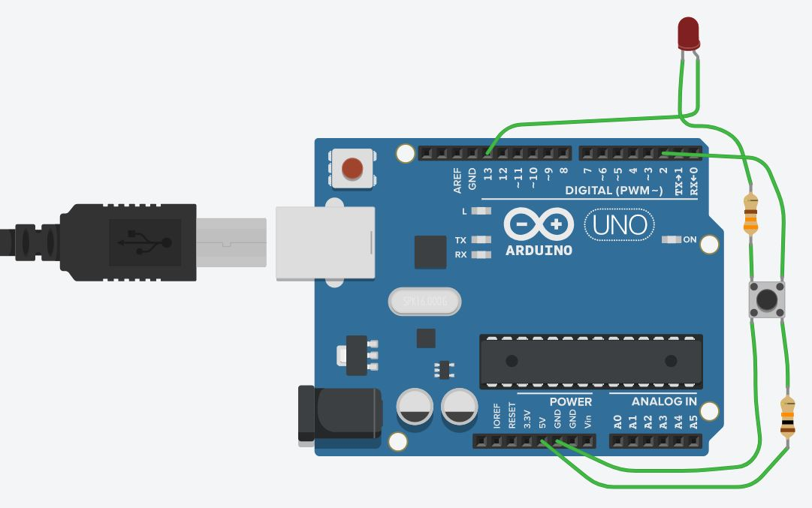

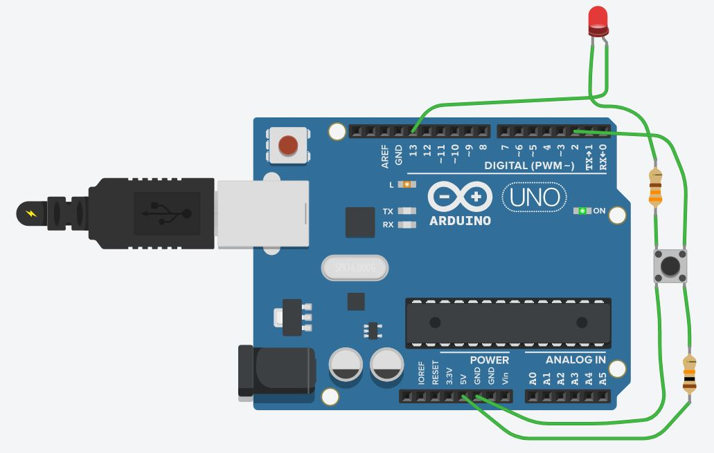

When trying to create this part 1 circuit, the first challenge was to find the anode and the cathode of the LED and this was solved by trying both configurations and it was determined that anode is where the positive end goes, and cathode is where the ground wire attaches. Another challenge was about the mechanisms of the push button. Normal slide switches have connect and disconnect states with 2 ends but this had 4 terminals. It was learned that 2 parallel circuits run below the button and once its pressed, both the circuits are connected. The circuit goes from 5v to 10k resistor, then the push button and then to pin 2, then the microcontroller then out of pin 13 and then to the anode of the LED and then out of the cathode and then the second resistor and then to the ground.

Part 2:

This circuit was very straight-forward without much difficulties. The circuit beings from pin 9 and goes to the piezo element and then to ground. It buzzes after each second.

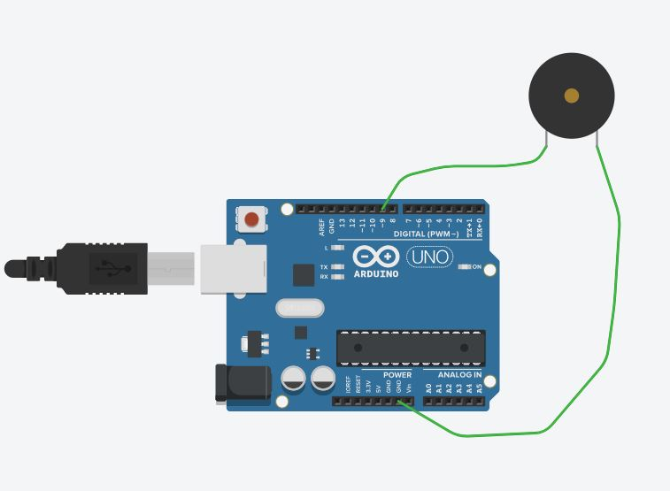

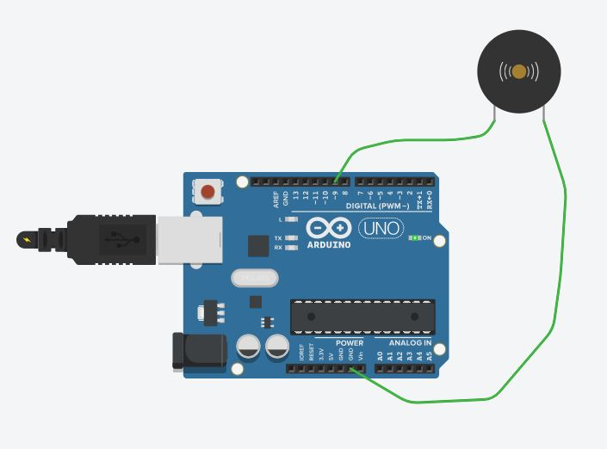

Part 3:

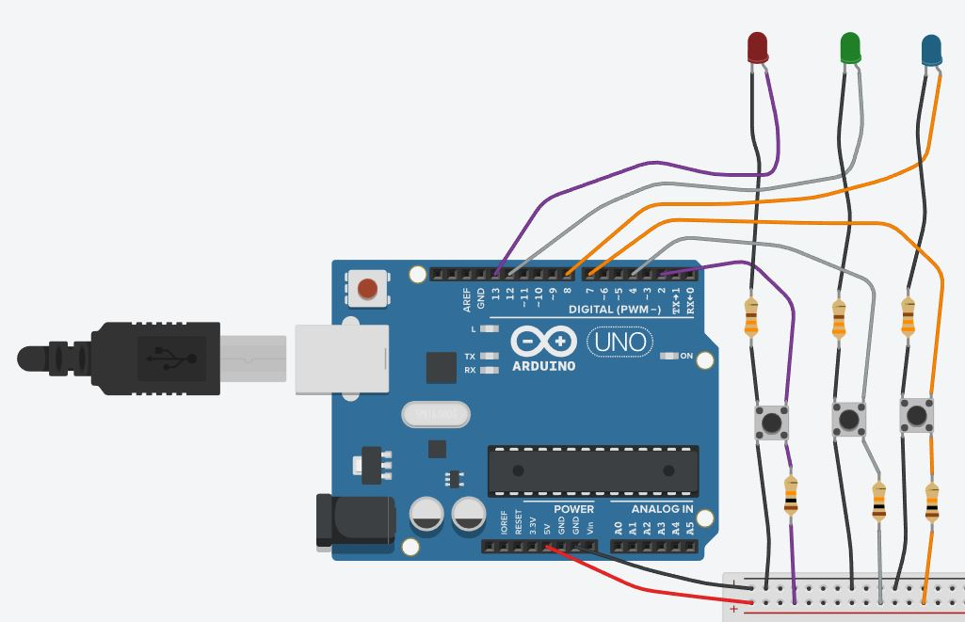

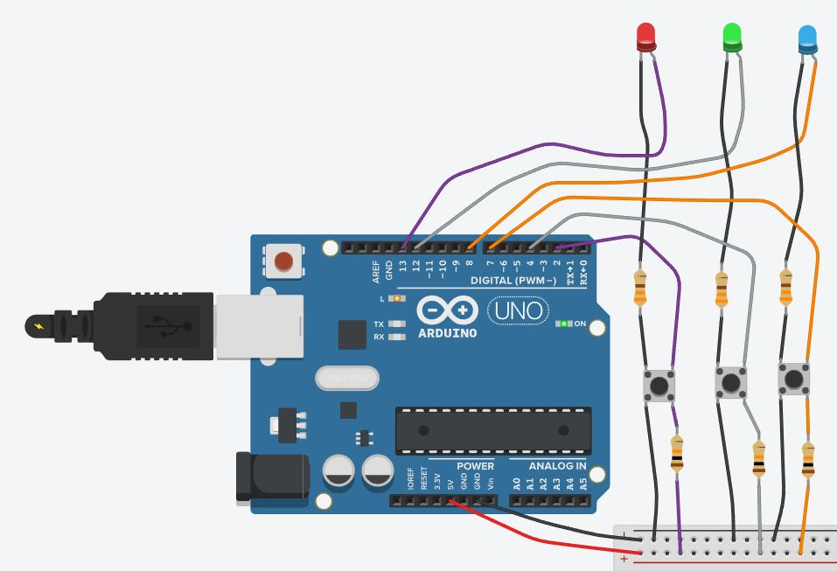

Part 3 was rather frustrating. Though, the concept was simple and when implementing the code for multiple LEDs, I began with the right extrapolation of the base code. However, when building the circuit out, I’ve had complications with the wiring as regards to the breadboard. There were issues with resistors running in parallel or in series that, despite given different signals by the code, ended up all interdependent. For example, during the first tries, all LEDs began lit but all turned off in unison when pressed any of the buttons rather than the respective ones. That led to my doubting of the integrity of code instead of the circuit and I’ve tried different loop set-ups such as nested loops and multiple loops, tinkering with variable and parameters, etc. After exhausting many attempts, I’ve decided to redo the circuit with great reduction in utilization of the breadboard and went back to my original extrapolated code and it worked. The circuit is just a multiplication of the first one but with utilization of 4 more pin slots while keeping the same 5v source and ground.

Below is the circuit diagram:

